Supporting Information
In this study, an LC-MS/MS method with scheduled multiple reaction monitoring (MRM) was established and applied to quantitatively determine the contents of liquiritin, isoliquiritin, liquiritigenin, and isoliquiritigenin in LTF. Comprehensive methodological validation of the quantitative method has also been completed. Due to the limitation of the research period, the intermediate precision of the method was evaluated for only three consecutive days.
1. Experimental
1.1. Chemicals and reagents
The reference standards of liquiritin, isoliquiritin, liquiritigenin, and isoliquiritigenin were purchased from Shanghai Standard Technology Co., Ltd. (Shanghai, China). The chemical structures of all reference standards were confirmed via nuclear magnetic resonance (NMR) and mass spectrometry (MS), and the purity of each standard was higher than 98%, which meets the requirements for quantitative analysis.
Acetonitrile, Methanol (Fisher Scientific, NJ, USA) and formic acid (Sigma–Aldrich, MO, USA) were LC-MS grade. Ultrapure water was purchased from Wahaha Corp. (Bejing, China).
1.2. Sample preparation
LTF lyophilized powder was accurately weighed, dissolved in methanol with ultrasonic assistance, and diluted to a final concentration of approximately 1 mg/mL. The prepared stock solution was further diluted 100-fold and then subjected to LC-MS analysis.
Liquiritin, isoliquiritin, liquiritigenin, and isoliquiritigenin were accurately weighed, dissolved in methanol by ultrasonic treatment, and volumetrically diluted to approximately 1 mg/mL to prepare individual standard stock solutions. Subsequently, the above stock solutions were separately collected and diluted with methanol to obtain a series of mixed standard working solutions with gradient concentrations for the establishment of the calibration curve. All the prepared standard stock solutions and working solutions were stored at 4 ℃ before analysis.
1.3. Chromatographic and mass spectrometric instrumental conditions
The analysis was performed using an ExionLCTM UHPLC system coupled to a Triple QuadTM 4500 mass spectrometer (AB SCIEX, Foster City, CA, USA). Chromatographic separation was performed on an HSS T3 C18 column (100mm×2.1mm, 1.8μm, Waters). The mobile phase consisted of 0.1% formic acid aqueous solution (A) and 0.1% formic acid acetonitrile solution (B) at a flow rate of 0.4 mL/min. The gradient conditions were as follows: 0-7 min, 20%B-70% B. The column temperature was maintained at 40 °C, and the injection volume was 5 μL.
MS analysis was performed in negative ion mode with scheduled multiple reaction monitoring (MRM) scanning. The ESI source conditions were set as follows: curtain gas, 40 psi, GS1, 55 psi, GS2, 55 psi, ion spray voltage, −4.5 kV; ion source temperature, 500 ℃. Compound parameters were optimized by direct manual tuning with infusion standard solution. The standard stock solution was diluted with a solvent consisting of Acetonitril-H₂O (50:50, v/v, 0.1% formic acid) to a concentration of 0.05-0.2 µg/mL. The solutions were then introduced via a syringe pump at a flow rate of 10 µL/min. The processing was performed using Analyst® software (version 1.7.3) and processed using SCIEX OS (version 3.4.0.19154).
1.4. Validation of the quantitative analysis method
Method validation was carried out according to the guidelines of the Chinese Pharmacopeia (China Pharmacopoeia Committee, 2025). Calibration curves were constructed using mixed standard working solutions at five concentration levels, with linear regression performed by plotting the peak area of each analyte against its concentration (X).
The limit of detection (LOD) was defined as the lowest concentration of an analyte that can be reliably detected at a signal-to-noise (S/N) ratio of 3:1. The limit of quantification (LOQ) was defined as the lowest concentration that can be reliably quantified at an S/N ratio of 10:1.
Precision was evaluated by assessing intra-day and inter-day variations. For intra-day precision, standard solutions were measured six times within a single day. For inter-day precision, the same mixed standard solutions were measured on three consecutive days. The relative standard deviation (RSD) of the concentrations was calculated to express precision.
Accuracy was assessed by a spike-and-recovery test. A reference standard solution was spiked into the LTF sample solution at a concentration equal to the endogenous analyte concentration in the original sample. Six replicate samples were prepared and analyzed to determine the recovery. The recovery percentage was calculated using the following formula:
Recovery (%) = (measured value - original value) / addition value×100%
Repeatability was determined by calculating the RSD of six independent LTF sample preparations processed using the same method. For the stability test, sample solutions were analyzed at 0, 2, 4, 8, 12 and 24 h.
2. Results
2.1. Optimization of ion pairs
To determine the optimal fragmentation modes for precursor ions (Q1) and product ions (Q3), the reference standards were directly infused into the mass spectrometer, and the corresponding product ion scan spectra were recorded. The optimized compound-dependent MRM parameters are summarized in Table 1.
2.2. Methodological Validation
The MRM chromatograms of the mixed standard solution and LTF sample are displayed in Figure 1. As shown in the MRM chromatograms, the four analytes were successfully separated and determined simultaneously within 6 minutes.
The calibration curves, linear dynamic ranges, correlation coefficients, LOD and LOQ values are summarized in Table 2. The precision, stability, recovery data as well as quantitative results are summarized in Table 3. The chromatograms of LOD and LOQ are presented in Figure 2. The calibration curves of the four target compounds are shown in Figure 3.
As shown in Table 2, all analytes exhibited good linearity, with correlation coefficients (r²) greater than 0.99 over wide dynamic ranges. The LOD and LOQ values for all analytes were lower than 0.50 ng/mL and 1.98 ng/mL, respectively. As shown in Table 3, the RSD values of intra-day precision, inter-day precision, repeatability, and stability for the four analytes were all below 5.78%. Furthermore, the recovery rates ranged from 82.33% to 109.92%, with RSD values lower than 13.15%. The established quantitative method possessed high sensitivity, favorable precision, reproducibility, selectivity, and analytical efficiency. Based on the above analytical procedures, liquiritin was identified as the predominant constituent in LTF lyophilized powder, with a content of 28.66 μg/mg.

Table 1. Optimized compound parameters of 4 analytes
No. | Analytes | t_{R} | MRM detection window | Target Scan Time | Q1 Mass | Q3 Mass | DP | CE
No. | Analytes | (min) | (sec) | (sec) | (Da) | (Da) | (volts) | (volts)
1 | Liquiritin | 1.95 | 30 | 0.5 | 417.1 | 255.0 | -80 | -27.0
2 | Isoliquiritin | 2.79 | 30 | 0.5 | 417.0 | 255.1 | -80 | -27.0
3 | Liquiritigenin | 3.33 | 30 | 0.5 | 255.0 | 119.0 | -80 | -30.0
4 | Isoliquiritigenin | 4.69 | 30 | 0.5 | 254.9 | 118.9 | -80 | -31.0

Table 2. Linearity, analytical limits of 4 analytes.
No. | Analytes | Calibration curve | r² | Dynamic range | LOD | LOQ
 |  |  |  | (ng/mL) | (ng/mL) | (ng/mL)
1 | Liquiritin | y=5644.00904x+987.71450 | 0.99894 | 0.44-565.00 | 0.03 | 0.44
2 | Isoliquiritin | y=6580.42613x+250.01877 | 0.99998 | 0.13-208.95 | 0.03 | 0.13
3 | Liquiritigenin | y=10307.18805x-954.47963 | 0.99921 | 1.98-63.40 | 0.50 | 1.98
4 | Isoliquiritigenin | y=16668.58896-76.29425 | 0.99913 | 1.82-58.30 | 0.45 | 1.82

Table 3. Precision, stability, repeatability, and accuracy of 4 analytes.
No. | Analytes | Precision  (RSD, %) |  |  | Stability  0-24h |  | Repeatability  n=6 |  |  | Accuracy  n=6 |  |  | Content in LTF  Lyophilized powder
No. | Analytes | intra-day  n=6 | inter-day  n=3 |  | (RSD, %) |  | Content in LTF solution(ng/mL) | RSD (%) |  | Recovery (%) | RSD (%) |  | (μg/mg)
1 | Liquiritin | 0.96 | 2.31 |  | 5.78 |  | 357.79 | 5.01 |  | 109.92 | 9.12 |  | 28.66
2 | Isoliquiritin | 2.28 | 2.32 |  | 5.35 |  | 41.52 | 5.55 |  | 95.35 | 10.98 |  | 3.25
3 | Liquiritigenin | 1.28 | 1.75 |  | 5.69 |  | 6.54 | 4.23 |  | 85.11 | 13.15 |  | 0.52
4 | Isoliquiritigenin | 1.21 | 2.51 |  | 5.34 |  | 3.52 | 5.56 |  | 82.33 | 11.79 |  | 0.28

Figure 1. The MRM chromatograms of the mixed standard solution and LTF sample.

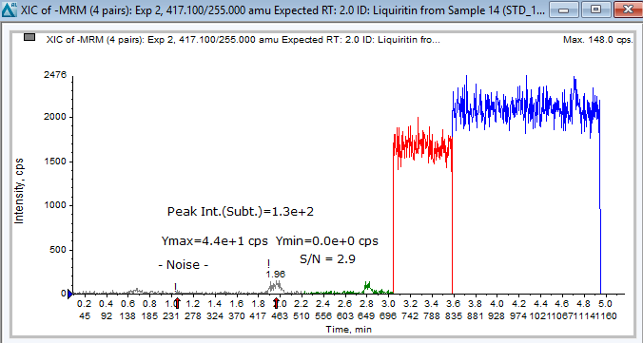
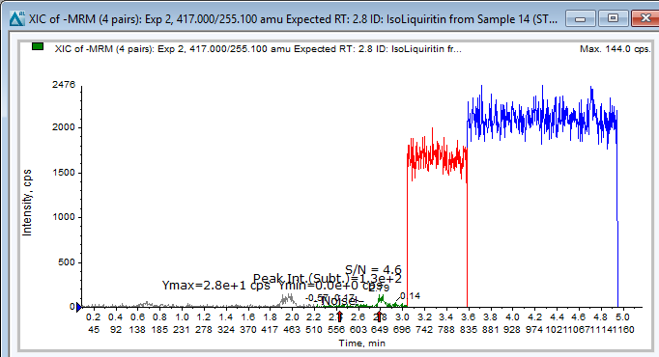
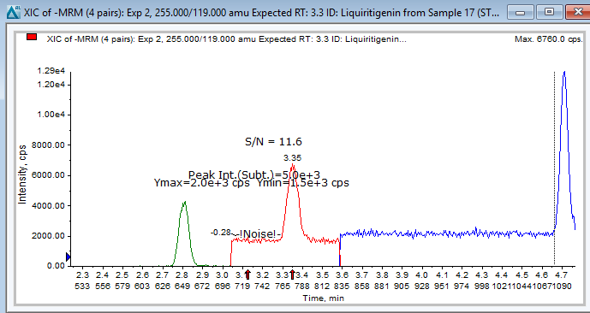
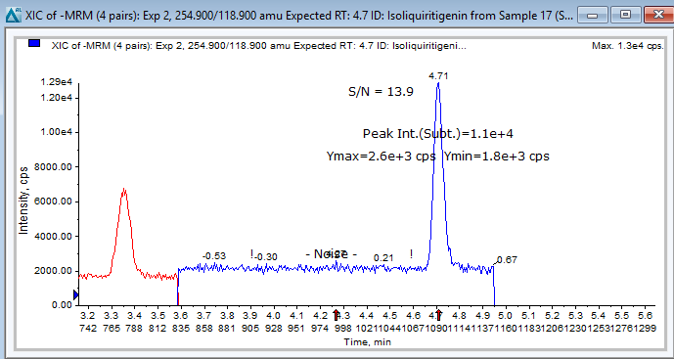
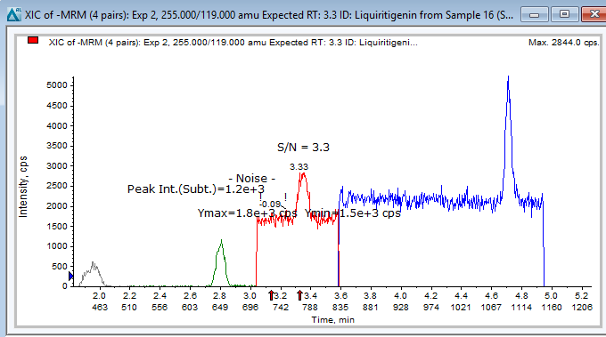
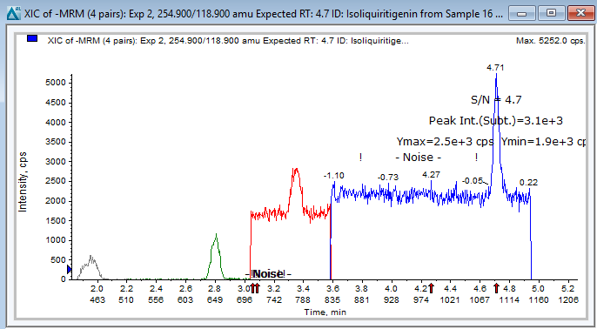
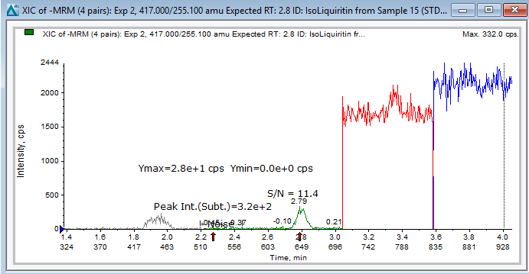
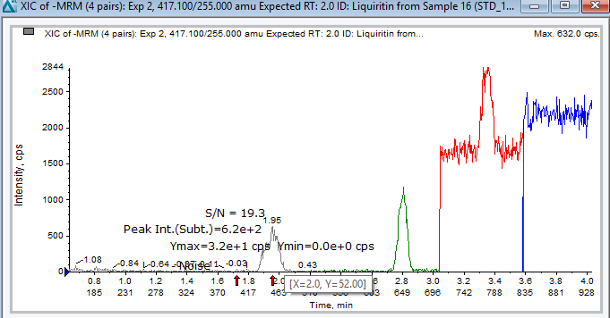
LOD
LOQ
LOD
LOQ
Figure 2. The chromatograms of LOD and LOQ

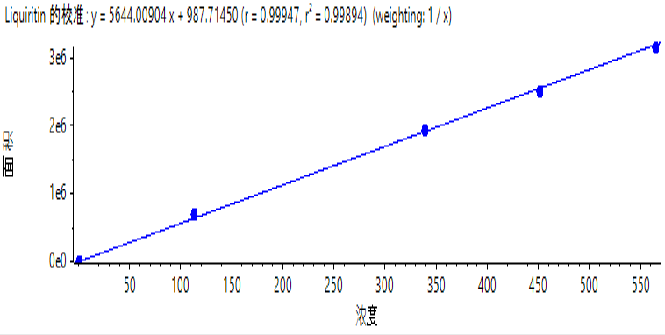
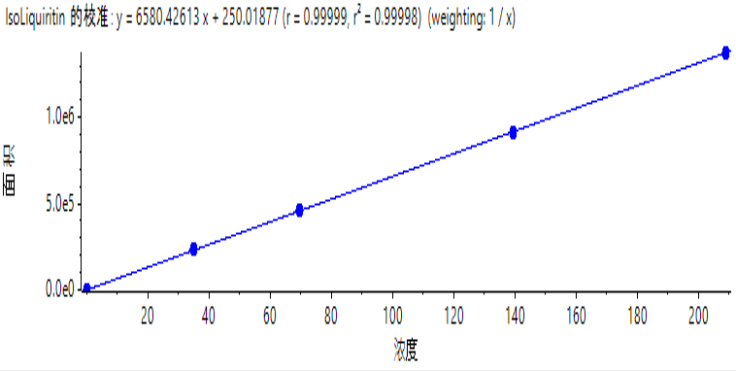
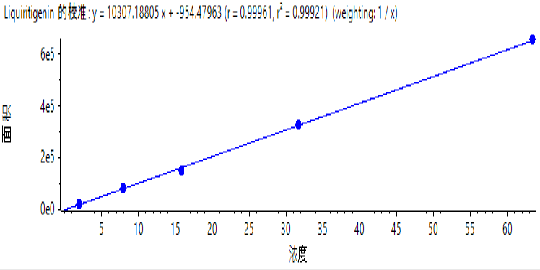
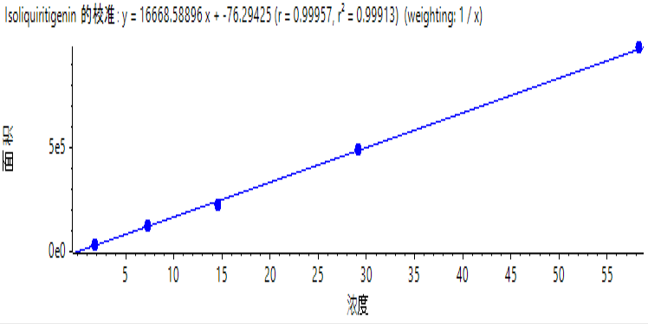

Figure 3. The calibration curves of liquiritin, isoliquiritin, liquiritigenin, and isoliquiritigenin.

